**Class Diagrams for**

**The “BSinCS” Game**

**Technical Project CSCE 543**

**Gaurav Palande, CSCE, CSULB**

**Gagandeep Bansal, CSCE, CSULB**

**All Card Classes (Collapsed)**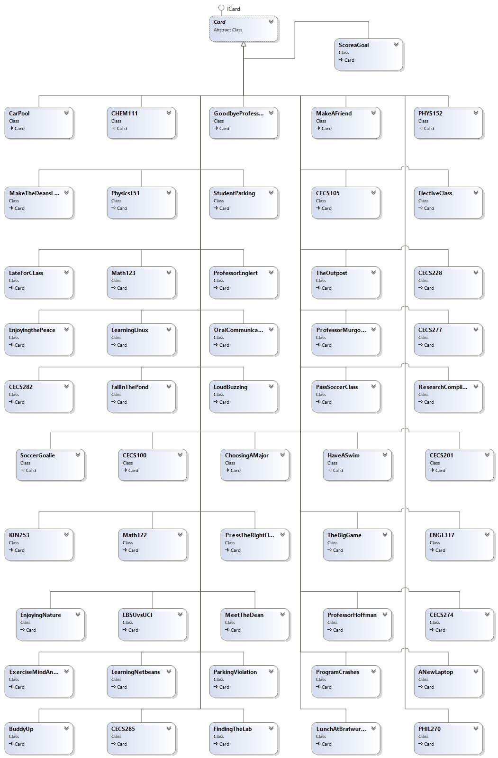

**All Card Classes (Expanded)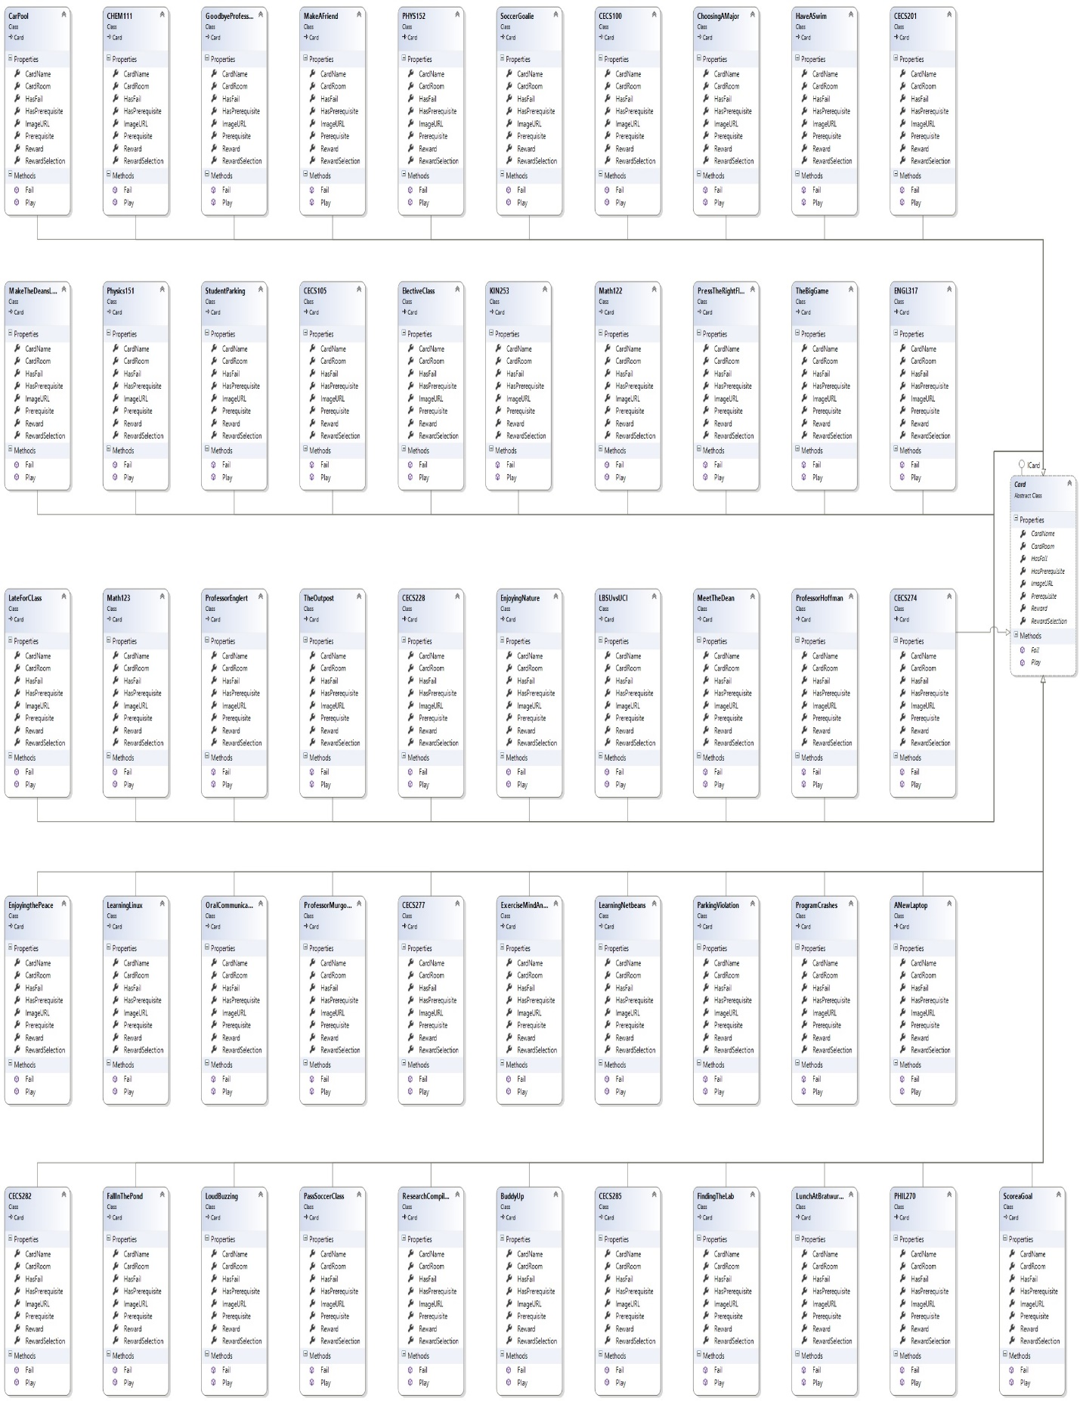Other Implemented Classes**